EXAMPLE: Japanese Government-Recommended STC Compliance Training System

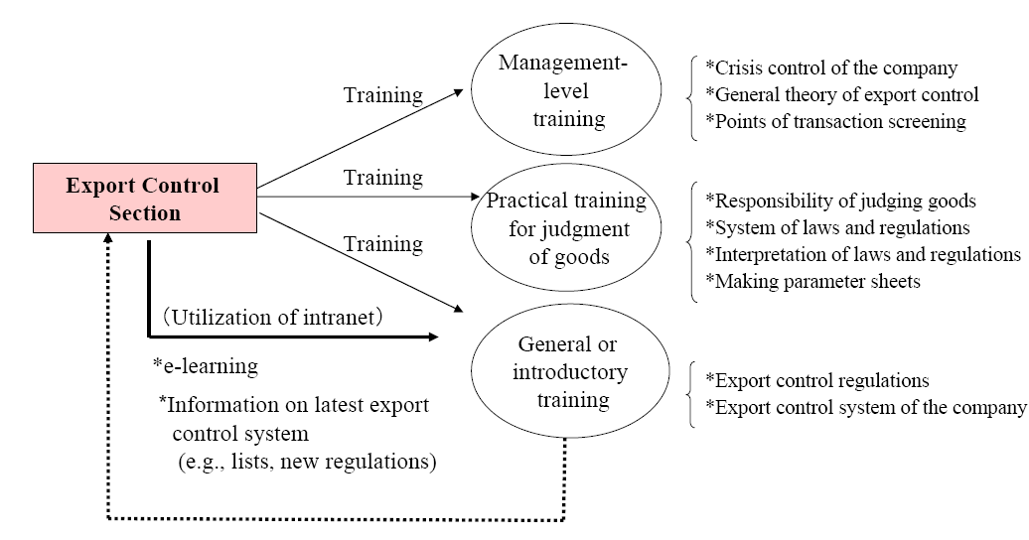

Source: “STC Compliance Training System,” Japanese Ministry of Economy, Trade, and Industry (METI), 2014, <http://www.meti.go.jp/policy/anpo/Internal-Compliance-program.pdf>.

